REC-CIS

GE23131-Programming Using C-2024

|  |  |
| --- | --- |
| **Status** | Finished |
| **Started** | Monday, 23 December 2024, 5:33 PM |
| **Completed** | Tuesday, 29 October 2024, 9:49 AM |
| **Duration** | 55 days 7 hours |

Top of Form

Question **1**

Correct

Marked out of 3.00

Flag question

Question text

Write a program that determines the name of a shape from its number of sides. Read the number of sides from the user and then report the appropriate name as part of a meaningful message. Your program should support shapes with anywhere from 3 up to (and including) 10 sides. If a number of sides outside of this range is entered then your program should display an appropriate error message.

Sample Input 1

3

Sample Output 1

Triangle

Sample Input 2

7

Sample Output 2

Heptagon

Sample Input 3

11

Sample Output 3

The number of sides is not supported.

Answer:(penalty regime: 0 %)

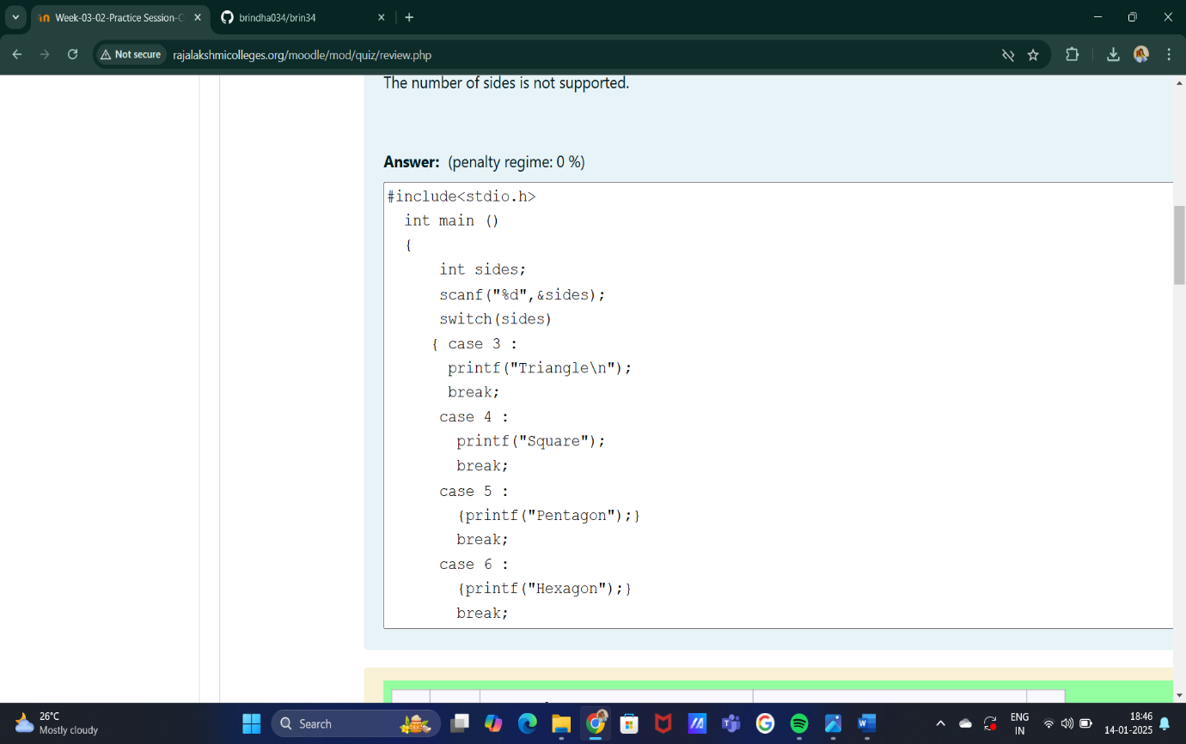

Feedback

|  | **Input** | **Expected** | **Got** |  |
| --- | --- | --- | --- | --- |
|  | 3 | Triangle | Triangle |  |
|  | 7 | Heptagon | Heptagon |  |
|  | 11 | The number of sides is not supported. | The number of sides is not supported. |  |

Passed all tests!

Question **2**

Correct

Marked out of 5.00

Flag question

Question text

The Chinese zodiac assigns animals to years in a 12-year cycle. One 12-year cycle is shown in the table below. The pattern repeats from there, with 2012 being another year of the Dragon, and 1999 being another year of the Hare.

Year                Animal

2000               Dragon

2001               Snake

2002               Horse

2003               Sheep

2004               Monkey

2005               Rooster

2006               Dog

2007               Pig

2008               Rat

2009               Ox

2010               Tiger

2011               Hare

Write a program that reads a year from the user and displays the animal associated with that year. Your program should work correctly for any year greater than or equal to zero, not just the ones listed in the table.

Sample Input 1

2004

Sample Output 1

Monkey

Sample Input 2

2010

Sample Output 2

Tiger

Answer:(penalty regime: 0 %)

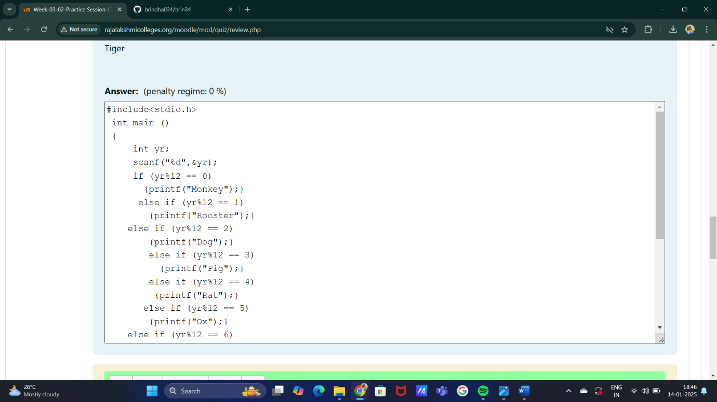

Feedback

|  | **Input** | **Expected** | **Got** |  |
| --- | --- | --- | --- | --- |
|  | 2004 | Monkey | Monkey |  |
|  | 2010 | Tiger | Tiger |  |

Passed all tests!

Question **3**

Correct

Marked out of 7.00

Flag question

Question text

Positions on a chess board are identiﬁed by a letter and a number. The letter identiﬁes the column, while the number identiﬁes the row, as shown below:

Write a program that reads a position from the user. Use an if statement to determine if the column begins with a black square or a white square. Then use modular arithmetic to report the color of the square in that row. For example, if the user enters a1 then your program should report that the square is black. If the user enters d5 then your program should report that the square is white. Your program may assume that a valid position will always be entered. It does not need to perform any error checking.

Sample Input 1

a 1

Sample Output 1

The square is black.

Sample Input 2

d 5

Sample Output 2

The square is white.

Answer:(penalty regime: 0 %)

Feedback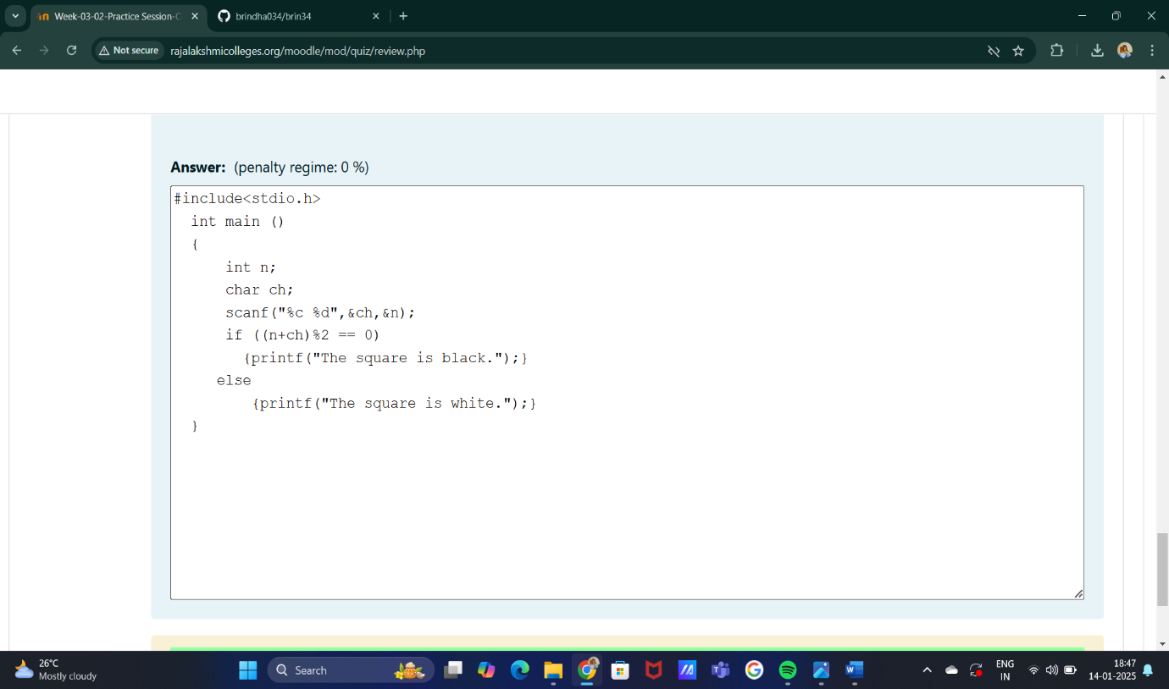

|  | **Input** | **Expected** | **Got** |  |
| --- | --- | --- | --- | --- |
|  | a 1 | The square is black. | The square is black. |  |
|  | d 5 | The square is white. | The square is white. |  |

Passed all tests!

Bottom of Form